**Basic Shell Commands 1-6:**

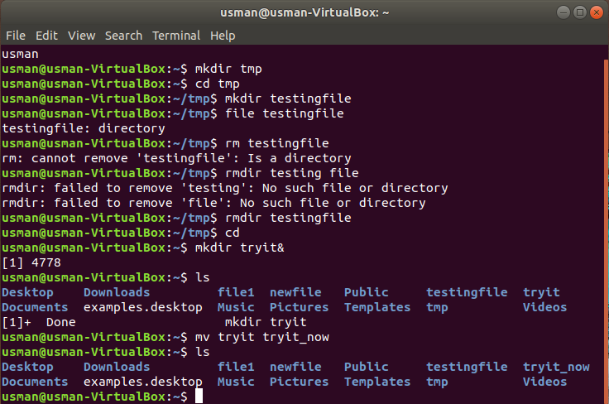

3.For checking filetype I used file filename command

4.rmdir is used to delete an empty directory. While, rm can be used to delete a on empty directory!

6.mv oldfilename newfilename

**Basic Shell Commands 7-8:**

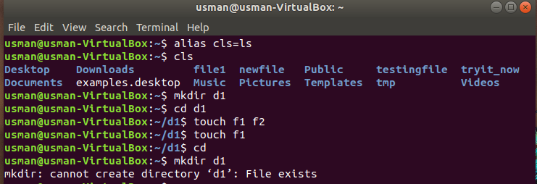

7.alias myclear=clear has been used in part 7.

8. cls has been used to clear screen as well as for ls command

**Answer To Questions:**

**1.**

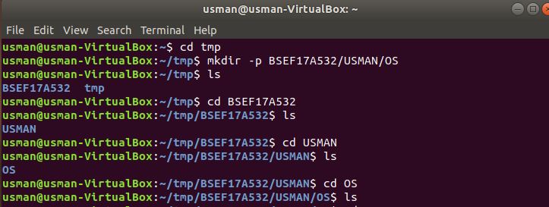**2.** 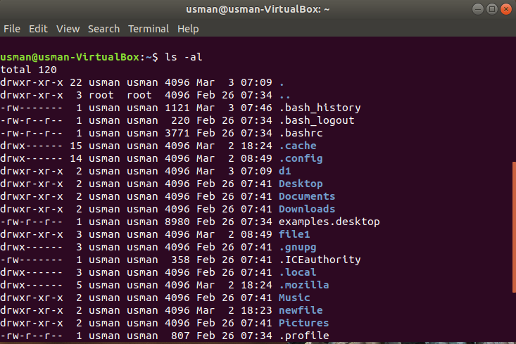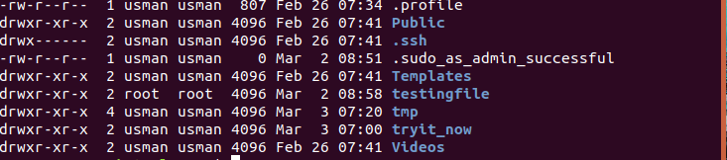

**3. One way to remove the directories is removing them one by one using**

**rmdir.**

**Other way is to use rm -r BSEF17A532**

**4.**

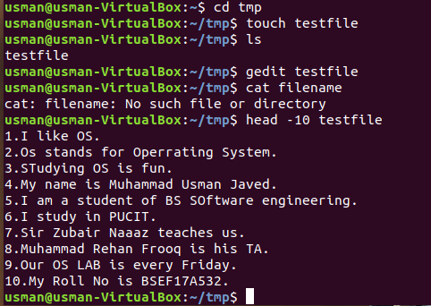

**5. No.** Test file doesn’t exist now. Its name is updated

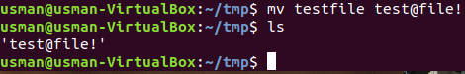

**6.**

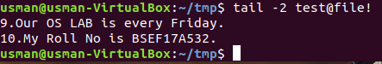

**7.**

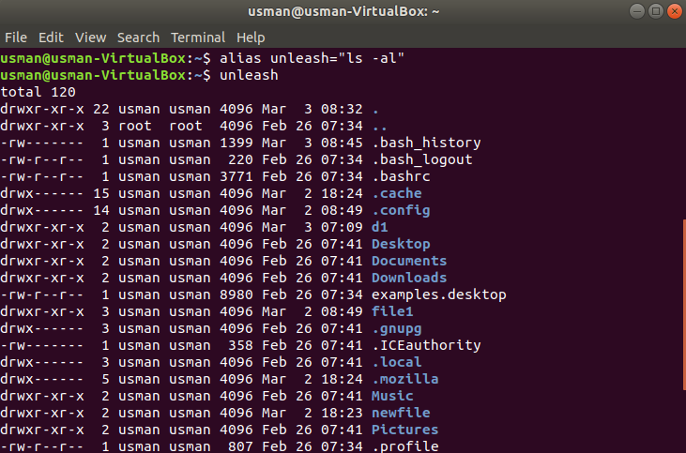

**8. man ls is used to see complete details of a command on the shell**

**9.type type is used.**

**10.rm -r**

**Relative and Absolute Path**

**1.**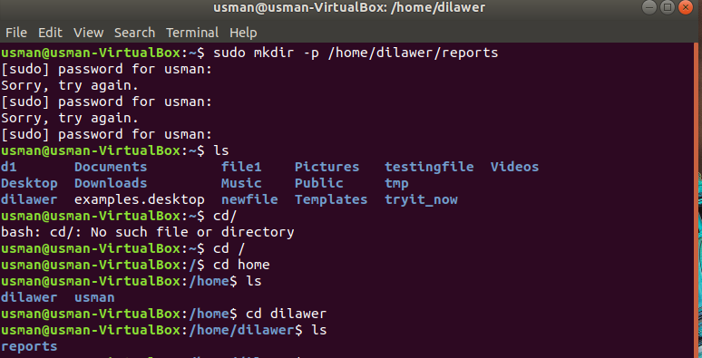

**2.**

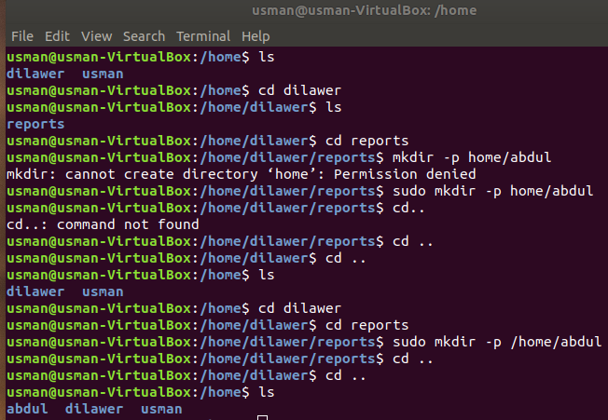

**3.**

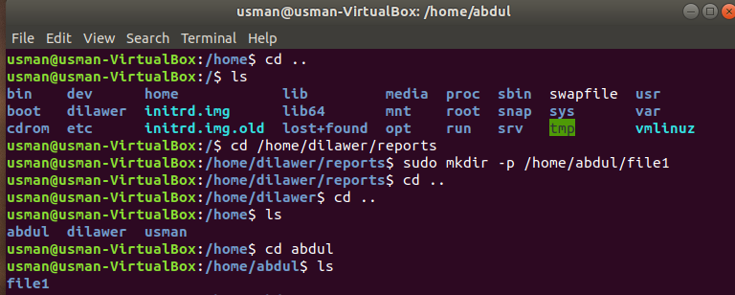

**4+5.**

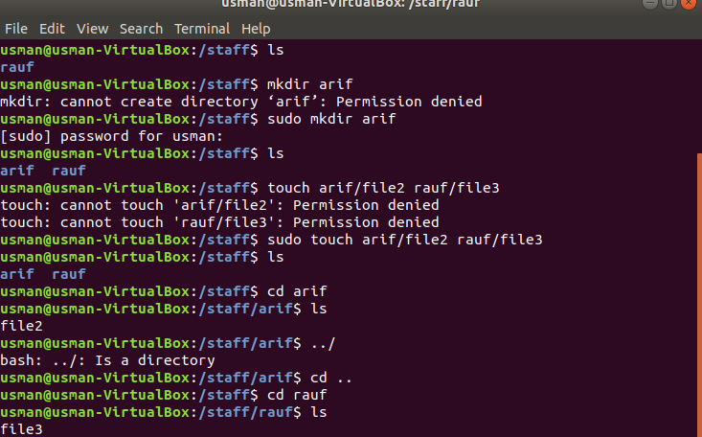

**6.**

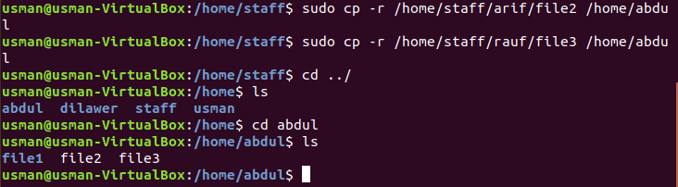

**7.**

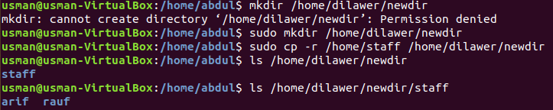

**8.**

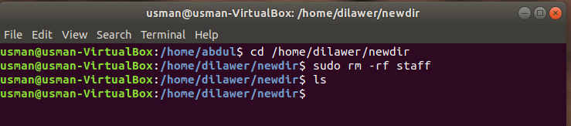

**9.**

